# (7082CEM)

# Coursework

Big Data Analytics and Visualization Using PySpark

MODULE LEADER: Dr. Marwan Fuad

Student Name: Monish Nallagondalla Srinath

SID:10969852

Replace this with the title of your own project

I can confirm that all work submitted is my own: Yes

Contents

(7082CEM) 1

Coursework 1

A. Apache Spark 4

1.INTRODUCTION

Every day, more than 2.5 quintillion bytes of data are produced, according to studies, and the number is continuously growing. In fact, by 2020, every individual on the world is expected to create 1.7MB of data each second . Google is the largest player in the sector, with 87.35 percent of the global search engine market share in 2021. This equates to 1.2 trillion searches each year and over 40,000 queries every second . This produced huge amounts of data, known as big data. Massive data sets generated from a number of sources are referred to as big data. These data sets, due to their magnitude and complexity, cannot be collected, stored, or analysed using any of the existing traditional procedures. As a result, several tools, including as NoSQL, Hadoop, and Spark, are used to investigate massive data sets. Using big data analysis technologies, we collect various types of data from more diverse sources, such as digital media, web services, business applications, machine log data, and so on.

Artificial intelligence, particularly machine learning, has become increasingly important in today's fast-paced world of information technology. A diverse set of resources has been discovered using a variety of techniques in order to process products and services quickly while maintaining high standards. Machine learning methods, on the other hand, are difficult to implement because to their high cost and massive storage requirements for data, CPUs, and memory. To deal with huge amounts of data, sophisticated systems began to emerge. Spark is a well-known distributed data research computer that boasts impressive capabilities such as improved performance in huge datasets. While Spark supports a number of programming languages, for this study Python was chosen because of its unique features such as screen analysis, data visualisation, and quicker framework processing. Thereafter, PySpark, a Spark and Python hybrid, is used for managing Spark data in this study. Jupyter Notebook is a free online tool for writing and sharing live code, equations, visualisations, and text documents. Jupyter Project is in charge of Jupyter Notebook upkeep. Jupyter Notebooks is an IPython fork with an IPython Notebook project. Jupyter is called for the three primary programming languages that it supports: Julia, Python, and R. Jupyter comes with the IPython kernel, which allows you to write Python programmes, however there are presently over 100 additional kernels available. This open source tool includes Jupyter Notebook, Jupyter Lab, and Jupyter Hub, as well as a variety of plug-ins and modules to aid in the development of a collaborative application.

The data is based on a Google Play Store app. This data set was derived from the Kaggle data set and utilised in this study to analyse and visualise massive amounts of data. While the data obtained comprised 24 attributes , only attributes were chosen as the most appropriate for this study. PySpark was started using the installation step number once the dataset was chosen. Following that, the data set's pre-loading was done. After that, duplicates were eliminated, as well as columns with incomplete data. After then, the investigation was carried out. The discussion section includes an explanation of the graphics and associated algorithms.

2. DATA DESCRIPTION

This dataset collected is from Kaggle , google-play-store is one of the daily used apps in android , it is a preinstalled app which is used to download other apps , its one of the most import app in all the android phones , while downloading the applications form the playstore the users look for many things to make decision for downloading the app or not , after downloading the app the users are requested to give reviews for the application they have downloaded . so the data collected is of 14 attributes .

The characteristics are listed below, along with a brief explanation of each.

1. App Name: the application's name
2. App Id: website of the application
3. Category: The app's category
4. Rating: The app's overall user rating
5. Rating Count: number of ratings given to the application
6. Installs : number of installs made by users
7. Minimum Installs: maximum installs made by users
8. Maximum Installs: minimum installs made by users
9. Free: if its free to use or not
10. Price: The app's price.
11. Currency: the currency used to buy the app
12. Size: The app's size
13. Minimum Android: Minimum android version required to download and use the application .
14. Developer Id: ID of the developer
15. Developer Website: website address of the developer
16. Developer Email: email of the developer
17. Released: when the app was first released
18. Last Updated: The most recent version of the app is available on the Google Play Store.
19. Content Rating: Age group the app is targeted at - Children / Mature 21+ / Adult
20. Privacy Policy: policies made to use the app
21. Ad Supported: if the app has advertisements in them
22. In App Purchases: application may have some purchases which can be made to unlock more premium features
23. Editors Choice: choice made by the editors
24. Scraped Time: when the data is taken .

Out of these many attributes the useful attributes are very less since all the attributes cannot be used for the analysis of the data . so some attributes are not considered for the analysis of the data .

3.BRIEF OF PROJECT

Pyspark, which is part of the Spark platform, is used for the analytics and visualisations. This dataset was downloaded from Kaggle, an online platform with over 19,000 publicly available datasets, Above is a description of the data. The first configuration of the dataset will include cleaning the data as part of the pre-processing technique. Various visualisation tools and machine learning methods are used to gain a better understanding of the data once it has been processed and made available for study. The code is implemented in a jupyter notebook, which combines the programming languages of python and spark. Jupyter notebook is started using docker processing.

4.BACKGROUND STUDY

The installation procedures of the softwares used will be discussed in this segment and a brief introductions of the softwares utilised will be given .

## A. Apache Spark

Apache Spark is a data processing framework that allows large amounts of data to be processed quickly and spreads data processing tasks over several machines, either on its own or in conjunction with other distributed computing technologies. These two features are essential in the domains of big data and machine learning, where enormous data sets demand the utilisation of massive processing resources. Spark also relieves developers of some programming headaches by providing a user-friendly API that encapsulates the majority of the dreaded work of distributed computing and big data processing. Since its inception in 2009 at the AMP Lab at U.C. Berkeley, Apache Spark has become a major processing framework throughout the world. Spark is a programming language for SQL, streaming data, machine learning, and graph processing that is accessible in native bindings for Java, Scala, Python, and R. Banks, television companies, game studios, governments, and all of the major technological companies, including Apple, Facebook, IBM, and Microsoft, utilise it.

B .Architecture of Apache Spark

Apache Spark application is made up of two primary components: a driver that converts user code into many tasks that can be distributed among worker nodes, and executors that run on those nodes and complete the tasks that have been assigned to them. Some type of cluster manager is necessary to arbitrate between the two.

Spark may run the box in an independent cluster mode, which necessitates the installation of the Apache Spark framework and JVM on each machine in your cluster. However, it's more likely that you'll want to handle your on-demand worker allocation using a more complex resource or cluster management solution. Although Apache Spark may be used with Apache Mesos, Kubernetes, and Docker Swarm, in the industry, this generally means utilising Hadoop YARN (like the Cloudera and Hortonworks distributions do), Apache Spark can also be used with Apache Mesos, Kubernetes, and Docker Swarm.

Apache Spark is included in Amazon EMR, Google Cloud Dataproc, and Microsoft Azure HDInsight. Databricks, the company that employs the Apache Spark who are founders, also offers the Databricks Unified Analytics Platform, which is a comprehensive managed service that offers Apache Spark clusters, streaming support, integrated web-based notebook development, and optimised cloud I/O performance over a standard Apache Spark distribution.

C. PYSPARK

PySpark is a Python API for Apache Spark that was created in Python. Apache Spark is a distributed platform for analysing large amounts of data. Apache Spark may be written in Python, Scala, Java, R, and SQL in Scala. Spark is a computer that works with enormous amounts of data in both parallel and batch systems.



**https://www.infoworld.com/article/3236869/what-is-apache-spark-the-big-data-platform-that-crushed-hadoop.html**

D. Spark MLlib

Apache Spark also includes libraries for machine and graph analysis, which may be utilised in big data applications. Spark MLlib provides a framework for building machine learning pipelines that make it simple to extract functions, selects, and transformations from any structured dataset. Distributed clustering and classification algorithms, such as k-means and random forests, are implemented in the MLlib and may be easily moved into and out of particular pipelines. With Apache Spark, data scientists can train models in R or Python, save them with MLlib, and then import them into a production pipeline written in Java or Scala.

E.DOCKER

Docker is used to run pyspark , Docker containers enclose a piece of software in a filesystem that contains everything it needs to execute, including code, runtime, system tools, system libraries, and anything else that may be loaded on a server. This guarantees that the application continues to operate regardless of the environment.

F. MACHINE LEARNING

Linear regression

Linear regression is a method of predicting the relationship between a set of independent factors and numerical output variables (numerical).Multi-variable linear regression is used when there are more than one variable in the input variables. In other words, the dependent variable should be a linear mixture of other factors.

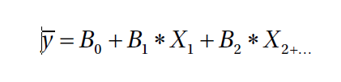

Here *X*1, *X*2,.. are the independent variables that are utilised to predict the output variable. The linear regression method generates a straight line that minimises the difference between the actual and expected values. Because only linearly separable data can be represented, a linear regression model cannot deal with nonlinear data; hence, polynomial regression is used in nonlinear data.

Decision tree regressor

Decision tree regression has a straightforward structure: it divides data into subsets, which are subsequently subdivided into smaller partitions or branches until they become "pure," indicating that all of the features within the branch belong to the same class. "Leaves" refers to these classifications.

* The top node symbolises the root in a tree classification.
* The features are represented by the internal node.
* The leaves symbolise the end result.

The decision tree regression approach can be used for regression and classification. When it comes to effectively fitting data, it has a lot of power, but it also has a high risk of overfitting the data. In decision trees, many splits depending on entropy or Gini indices can be visible. The deeper the tree, the more likely the data will be suffocated. To predict the target value, we'll use a decision tree with default value parameters in our case.

Random Forest Regressors

Random Forest Regressors are a form of regressor that is used to predict the outcome of an experiment. Random forest regressors are made up of a number of independent decision trees that have been built from various data samples. The purpose of combining these different trees is to successfully generalise them using majority voting or averages (in the case of regression). As a result, a random forest is a bagging strategy-based assembly process. It has the ability to be utilised for both regression and classification. Because decision trees have a tendency to outperform the data, random forests use prediction values to remove big variations from individual trees.

One of the most accurate machine learning methods is random forest. The accuracy of the model improves as the number of trees in the regressor grows. The rules are identical to those for the decision tree regressor .Random Forest makes use of several binary trees, each with its own set of input features and data cases. The final classification is determined by averaging the results of each binary tree. This principle underpins the bagging technique, also known as bootstrap aggregation. The entropy and information gain are calculated to determine the quality of a node split. The parameters tuned for random forest are the number of trees, the maximum depth of each tree, and the number of features to be randomly selected at each split.The feature selection algorithm is also based on this algorithm. Random Forests, unlike Decision Trees, can handle missing values and avoid overfitting

5. INSTALLATION OF DOCKER WITH STEPS AND SCREENSHOTS

The machine utilised to conduct this project has a hard disc drive with a capacity of 20 GB, 4 GB of RAM, and Ubuntu used in Virtual machines .

Step1: sudo apt install docker.io

In this step the 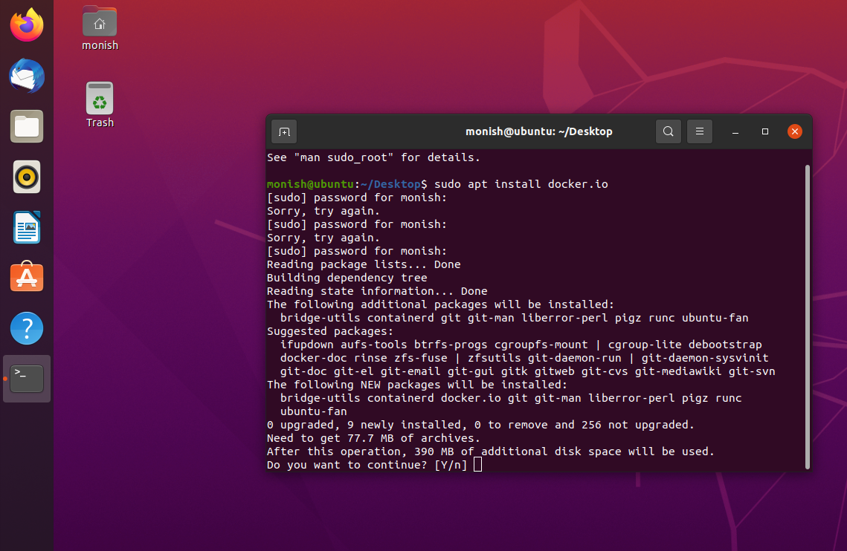

Step 2 : type y to agree to use additional disk space

Step 3: installation process starts

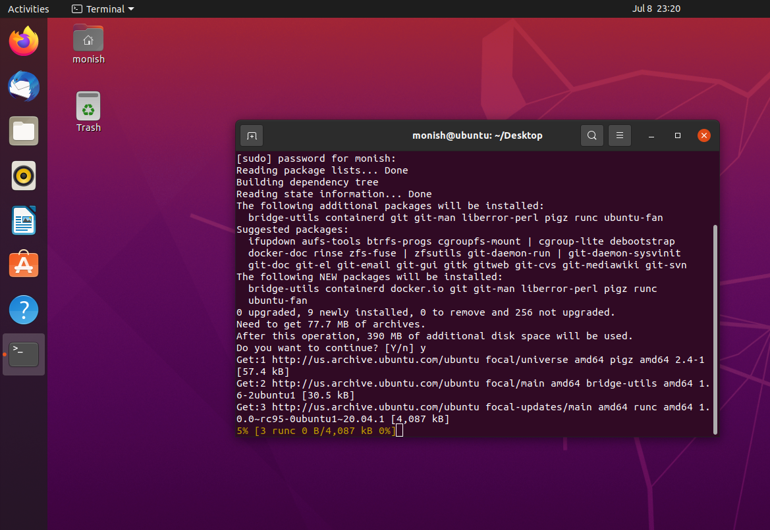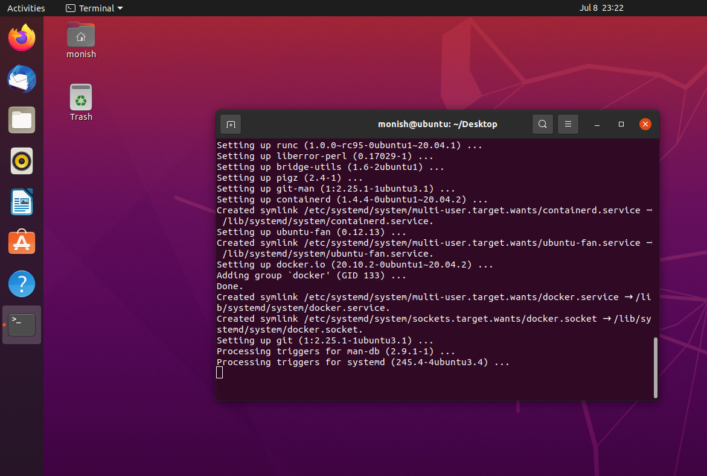

Step 6: checking the installed docker version , here it is 20.10.2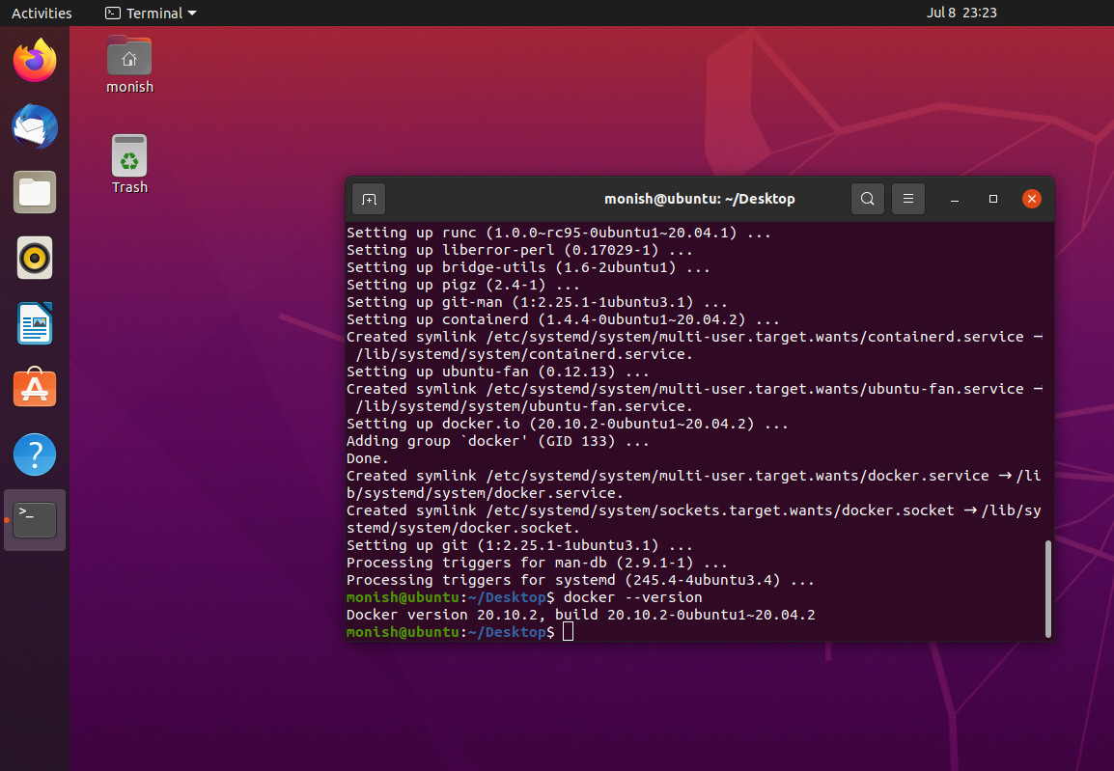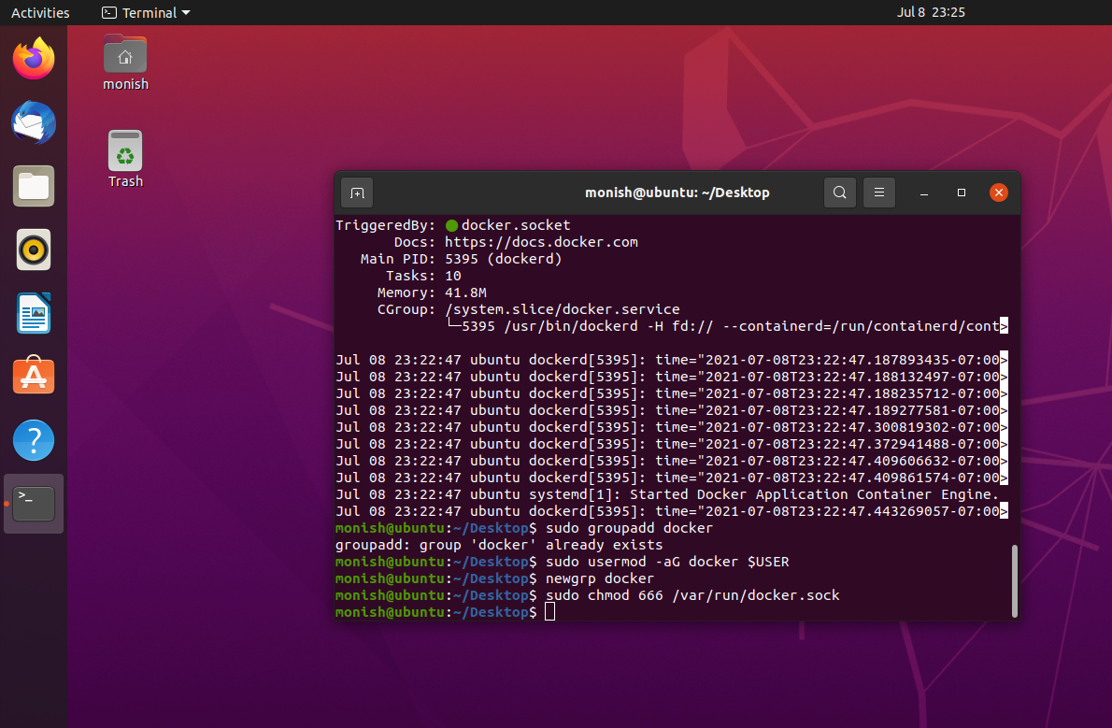

Step 7 : running ‘hello-world’ to check the docker working 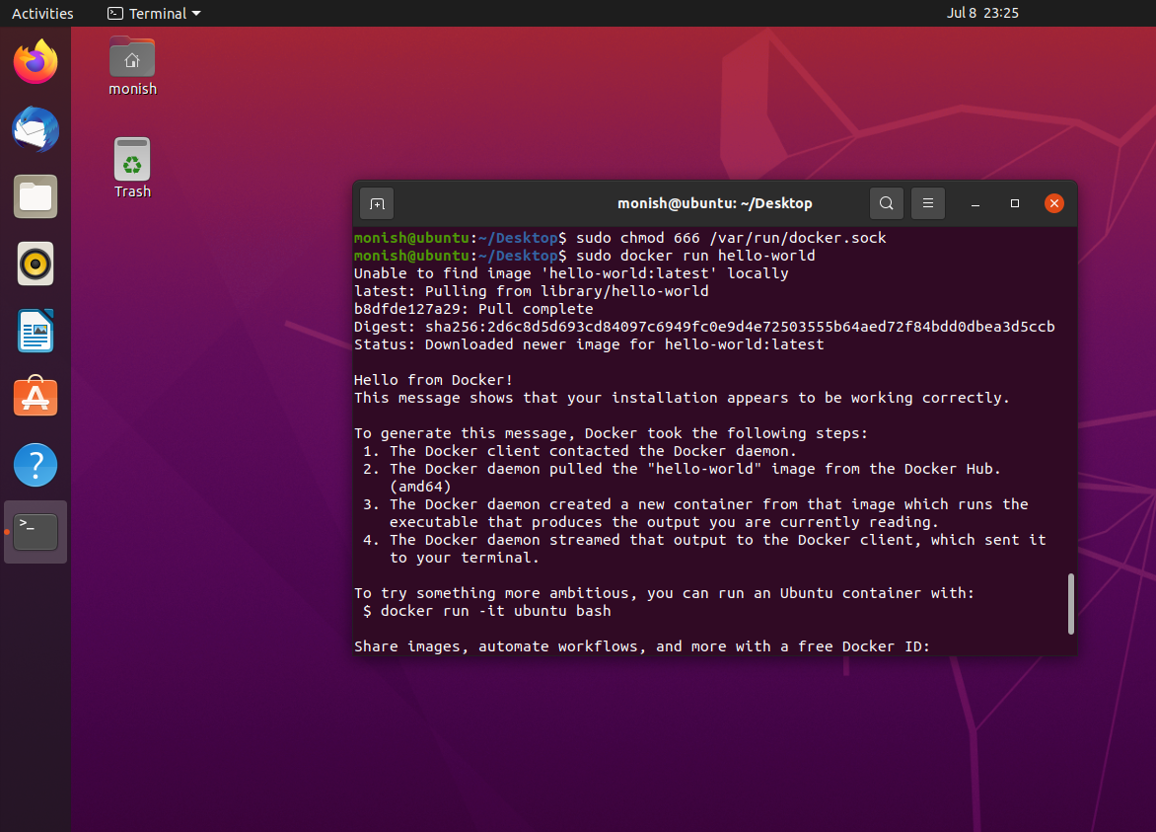

Step 8: installing jupyter notebook 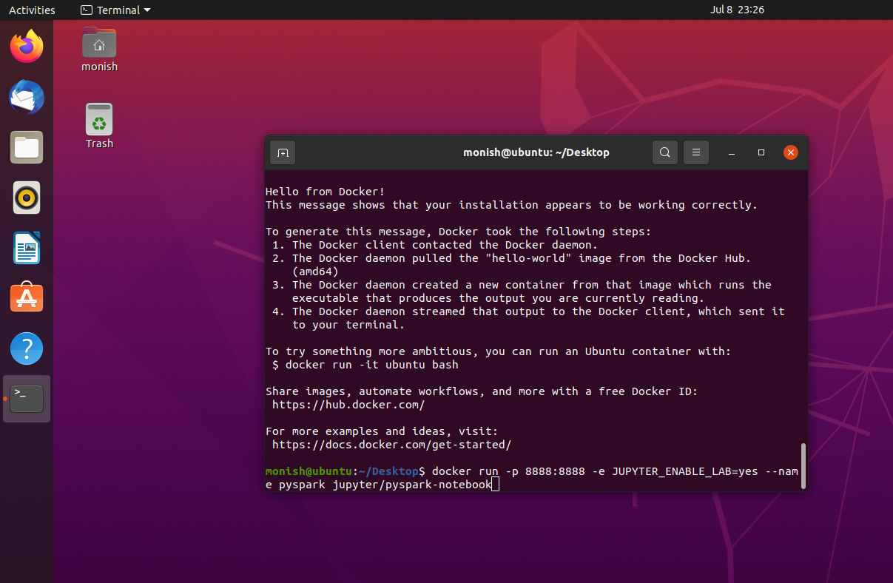

Step 9 : checking if jupyter notebook is successfully installed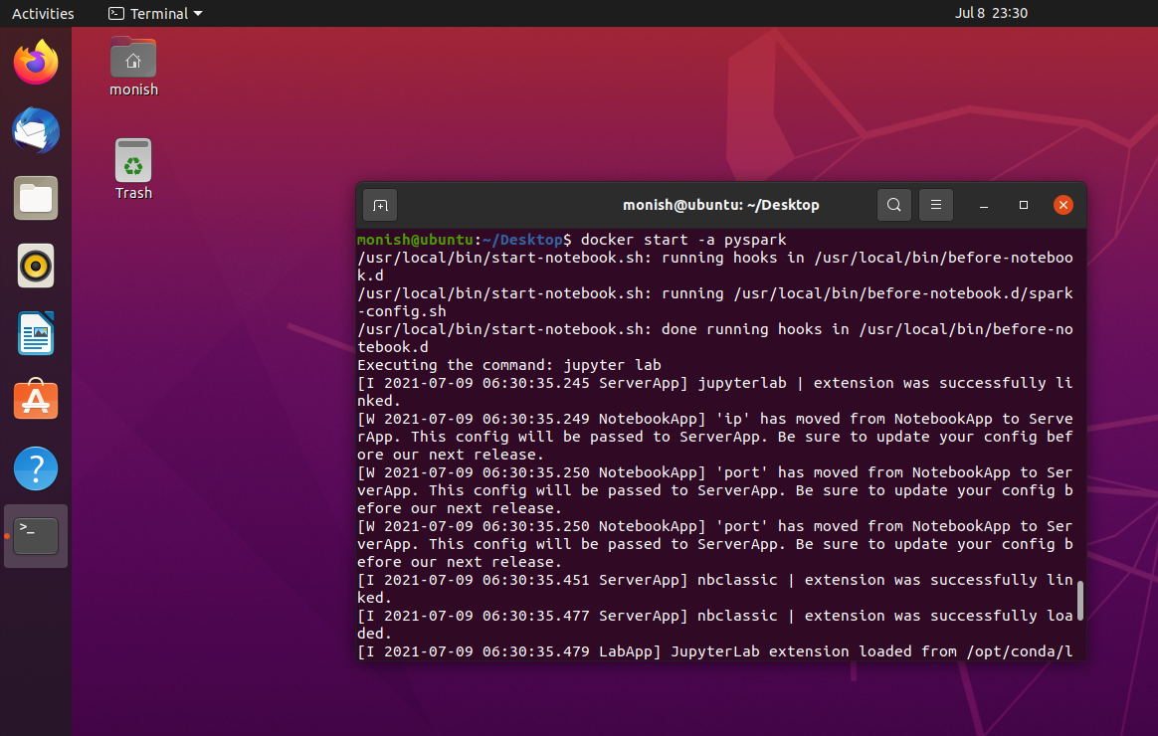

Step 10: clicking on open link to open jupyter notebook in Mozilla Firefox 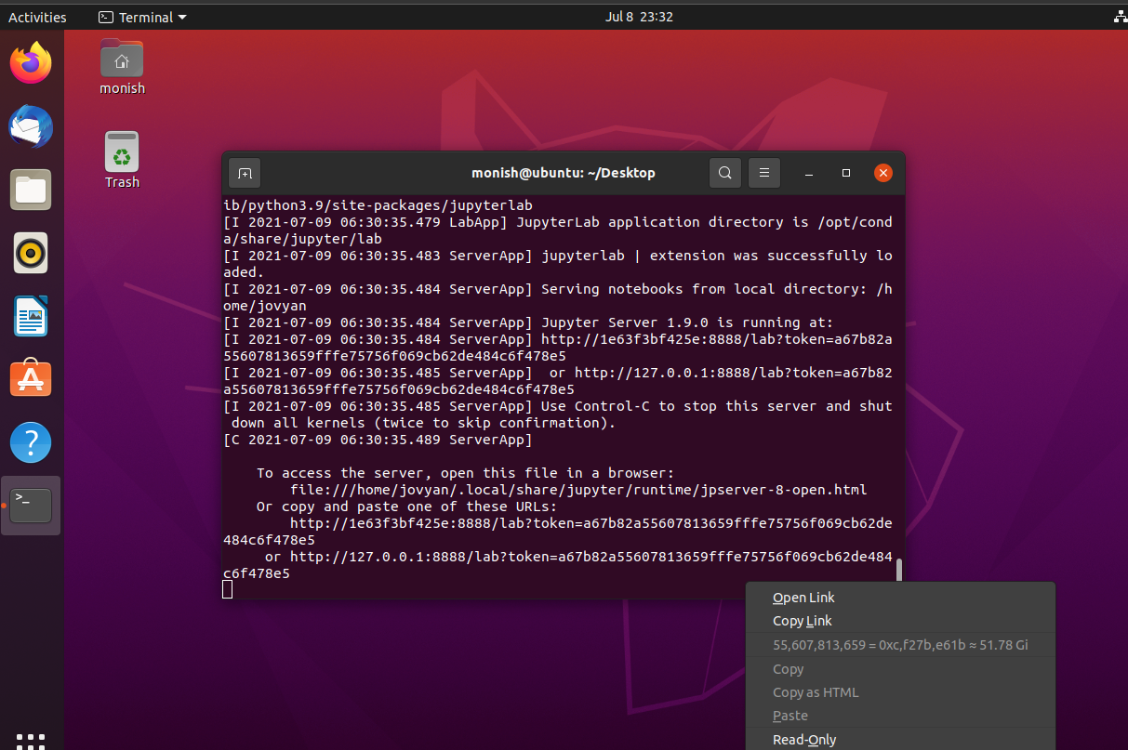

Step 11 : jupyter notebook opens 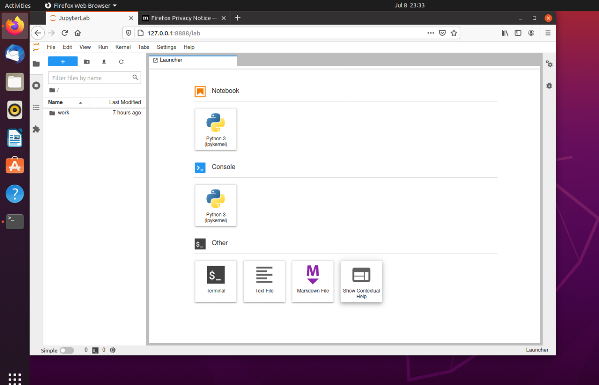

Step 12: notebook is created to write the code and perform the analysis 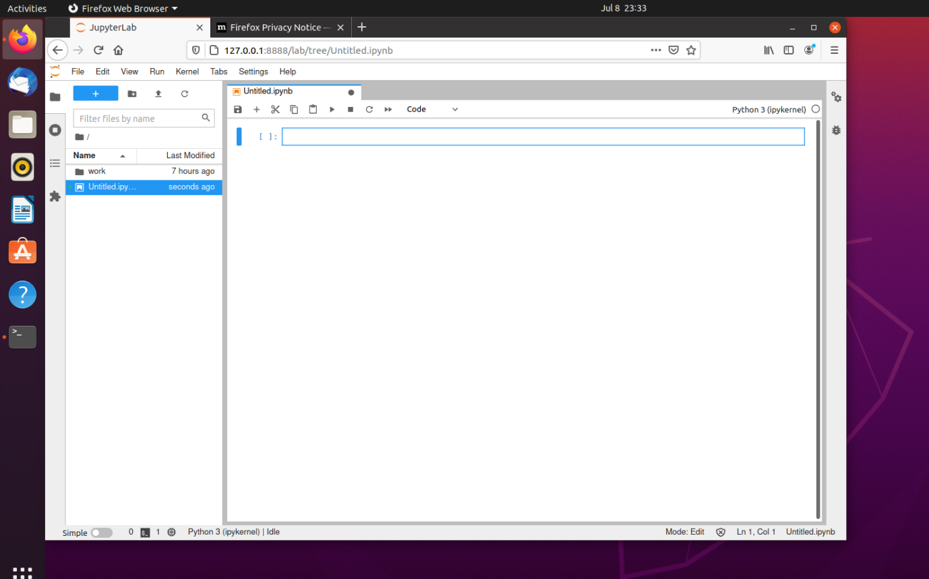

6. IMPLEMENTATION OF PYSPARK CODES ON JUPYTER NOTEBOOK

6.1 Using the pip install pyspark command to install pyspark on jupyter notebook.

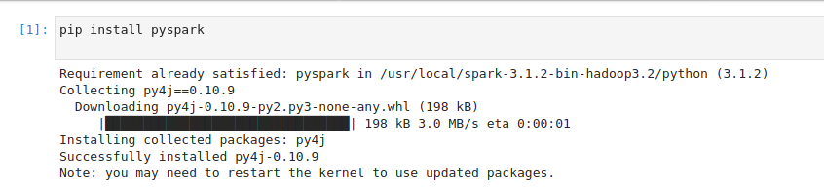

6.2 Creating spark session



6.3 Imports of some usefull libraries is done to run the code

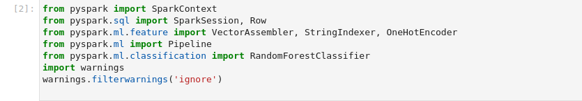

6.4 Importing the csv format data to jupyter notebook , since docker is used the file has to be uploaded .

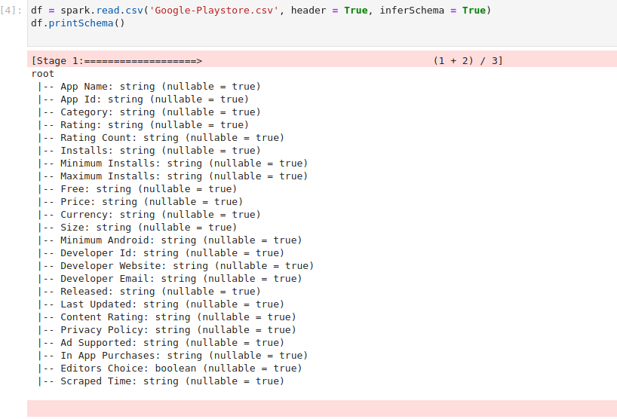

6.5 using pandas to check the transpose of the dataset so as to see the attributes .

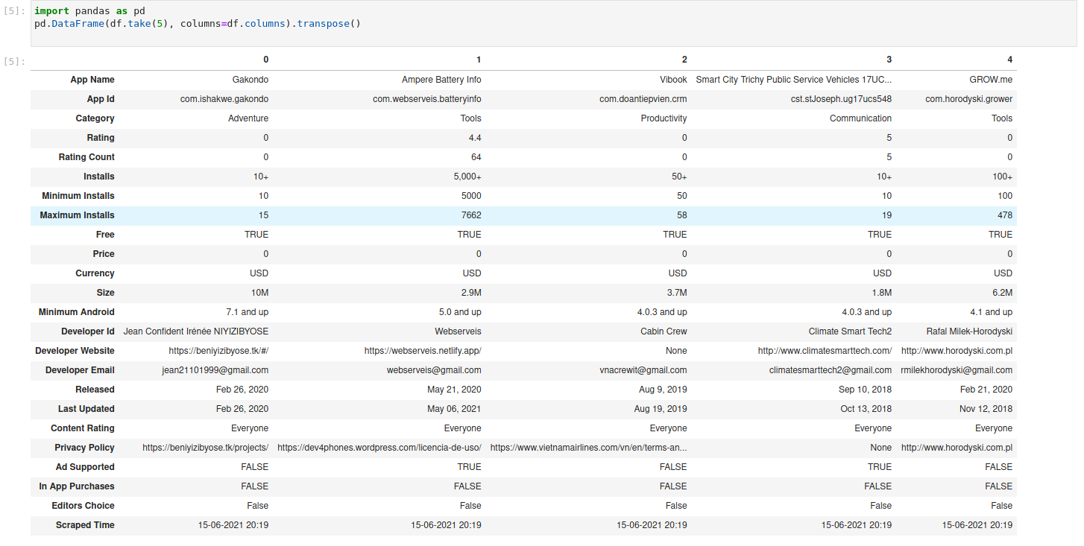

6.6 new variable “ggle” is taken and columns are called so as to refer which ones have to be changed for datatype ,since many columns were in strings , some of them were changed to Boolean and float type .

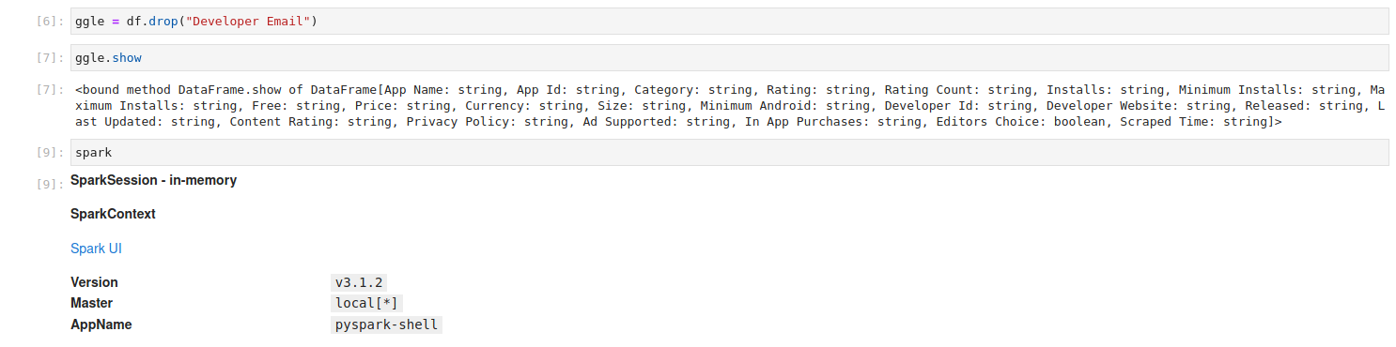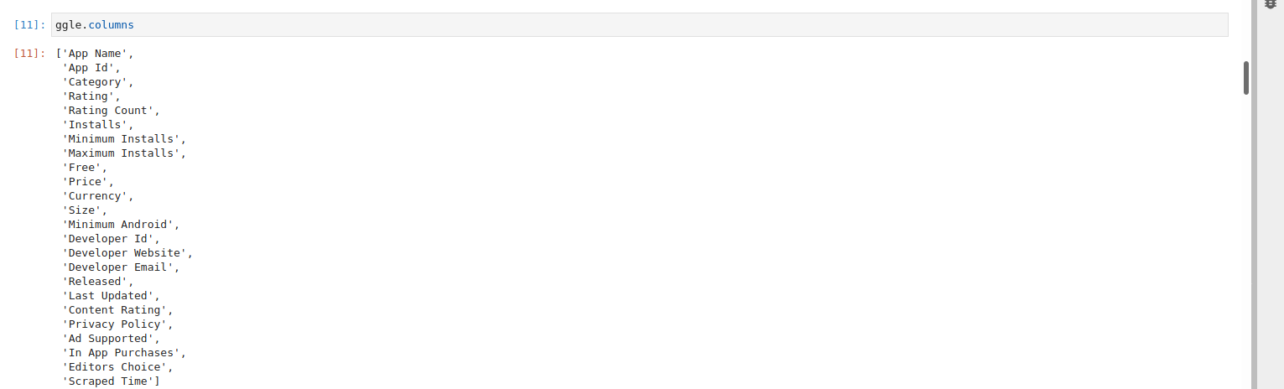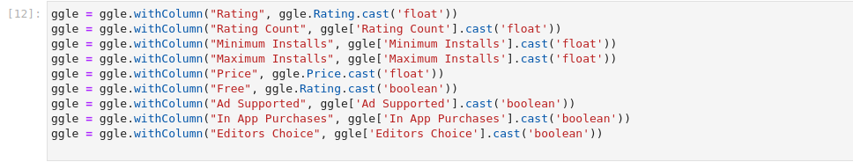

6.7 since there are 24 attributes and for analysis , there are many attributes which don’t have their role in the analysis which are to be dropped .

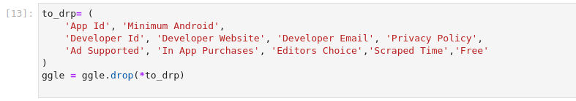

6.8 after the droppings of useless columns is done , this code is used to verify all the present available columns

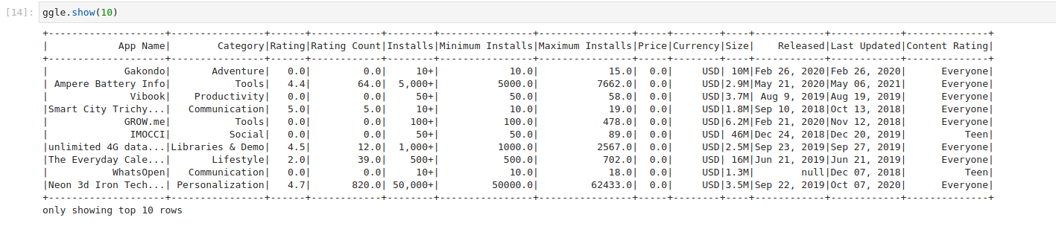

6.9 Schema is printed to check the data type of the column for further analysis

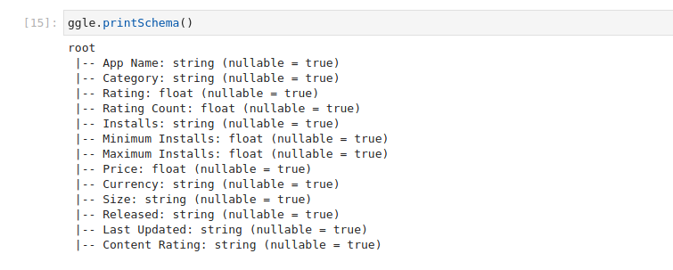

6.10 in the attribute category there are many values ,that is different sub categories from which the top 8 are taken , these top 8 are the the sectors of apps that are most commonly made .

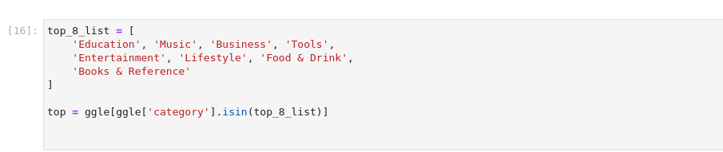

6.11 showing the top 8 list of categories .

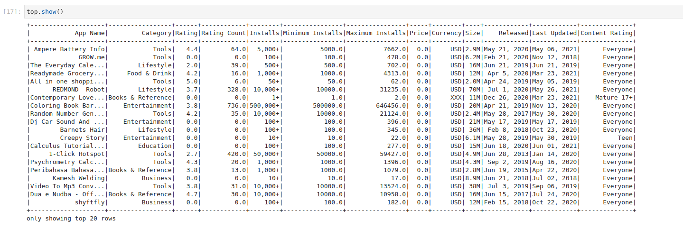

6.12 converting the data frame from spark into a panda data frame , and then seeing the converted data frame.

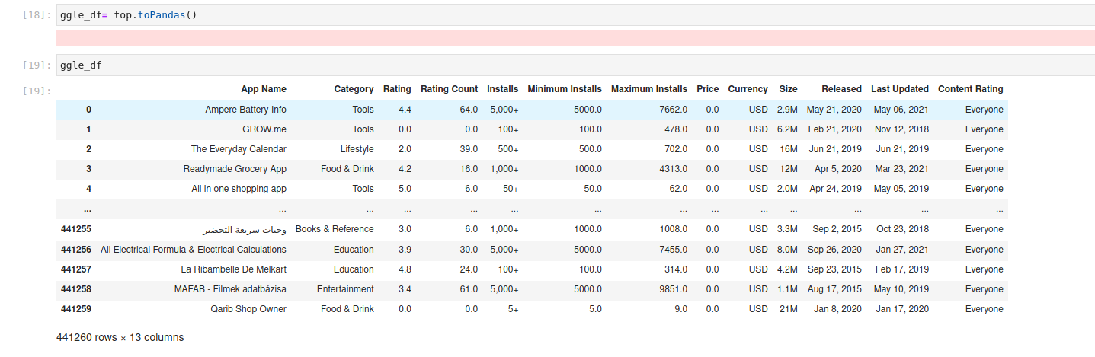

6.13 Importing the libraries and using them in short forms . Libraries are imported for visualisation and plotting

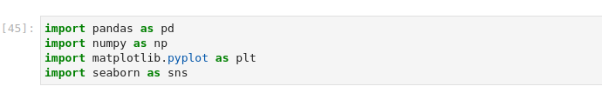

6.14 Subplot is plotted with X-axis as count and Y-axis Category , from this we can visualise that the Education category has the highest segment of count .

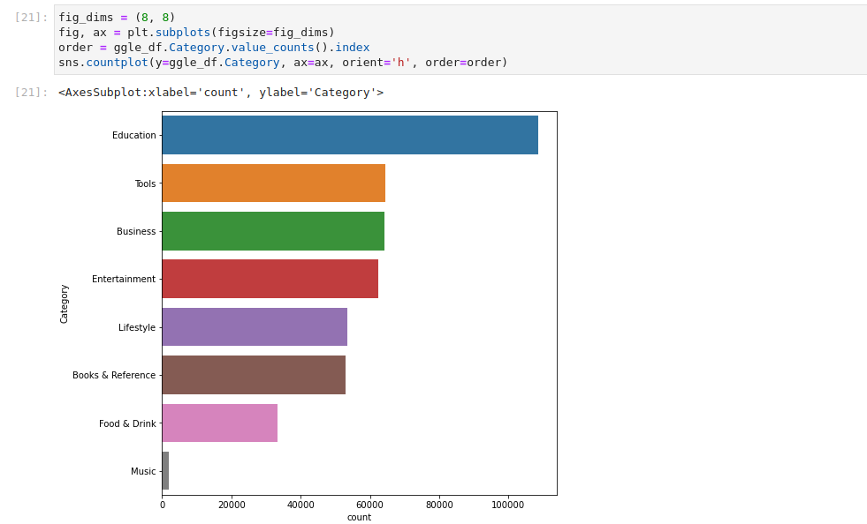

6.15 the code below is for plotting a barplot with X-axis as Content Rating , Content rating is who can use the application, here , Y- axis count ,the apps are created for more for everyone and the least created apps are adult rated apps , this can be because of the various laws which vary from countries .

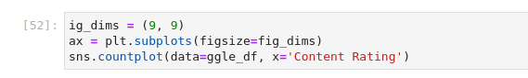

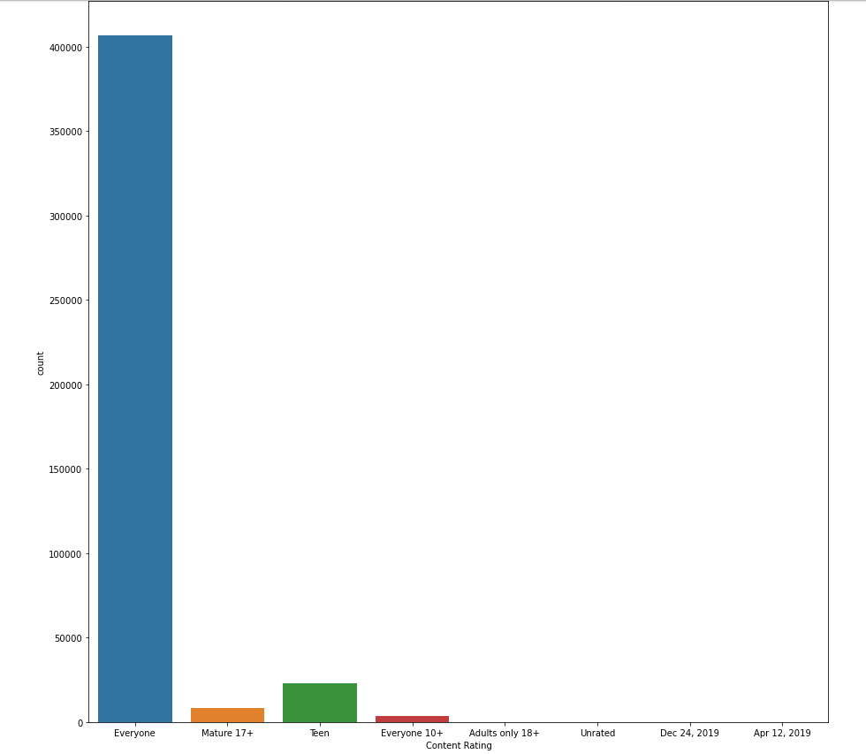

6.16 pie plot is plotted to visualise the percentages of category of apps created , top 8 categories are taken and visualised

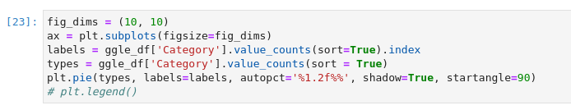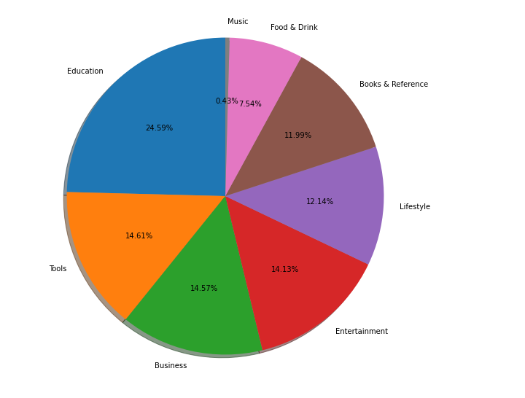

6.17 another bar plot is plotted with X-axis as Category and Y-axis as price , from this plot we can know that Business category apps and Books & Reference have almost nearly the highest prices in the category , then come tools and Lifestyle . This is because the business tools are created for efficient working and working well without glitches and with books also since they are paid . 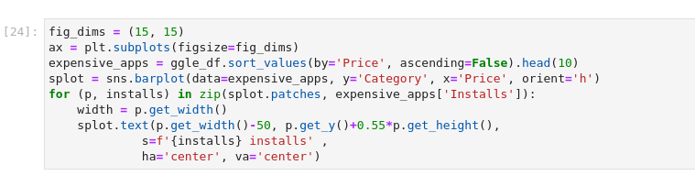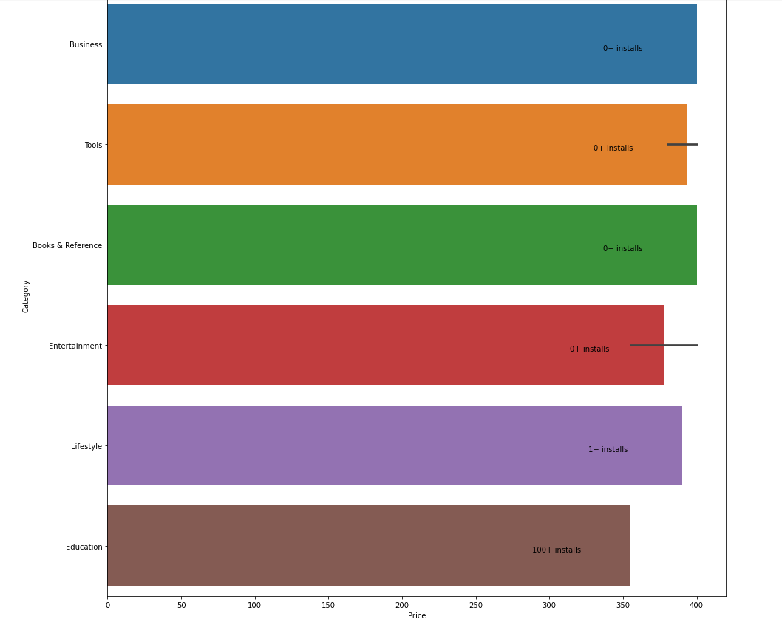

6.18 Correlation plot is plotted with the 5 attributes which are price , Rating , rating count , maximum and minimum installs , this correlation plot was created to check if the ratings of the app had relationship with price of the app or other attributers but , there was no relation between the price of the app and attributes used , so we can visualise that the price was set by the developer and not according to the users perspective.

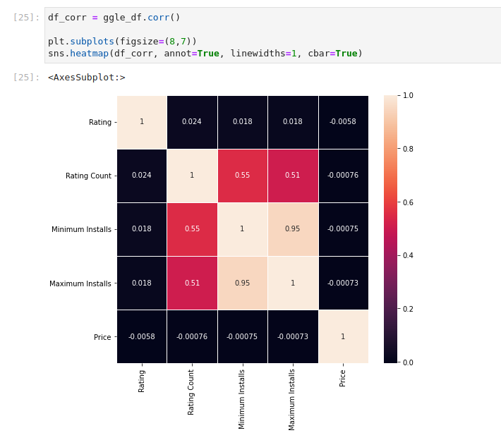

6.19 Visualising the dataset again,

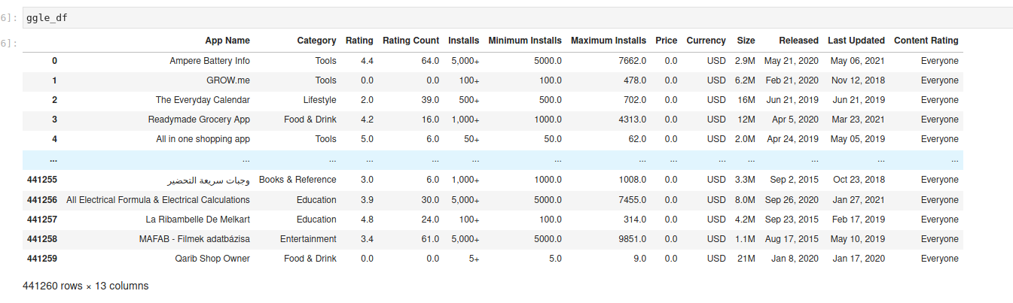

6.20 Machine learning algorithms are implemented , the first one being linear regressor , for implementation of these algorithms a cleaned dataset is taken so as to check if the ratings of the app can be predicted . cleaned dataset is imported into spark , and the schema is print to check if the file is imported successfully.

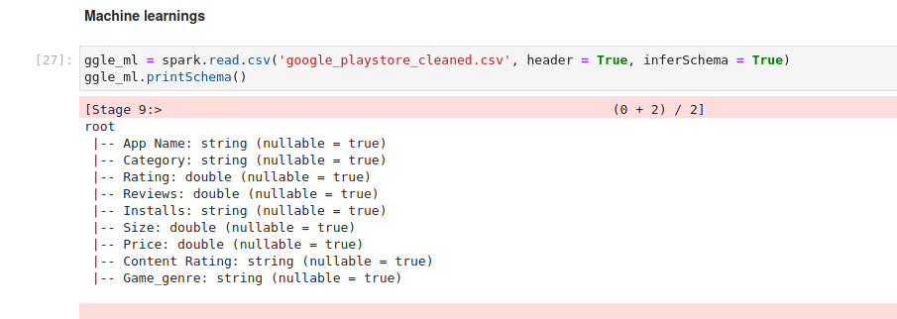

6.21 Vector Assembler a feature of pyspark is imported for vector assembly and Linear regressor a machine learning regressor is imported from pyspark for ML .

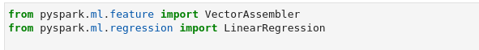

6.22 String indexer is a machine learning functionality in Pyspark that turns a single column to an index column.

Here category and content rating columns are converted into index colums as shown in the outputs below.

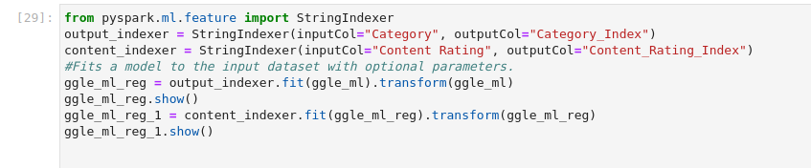

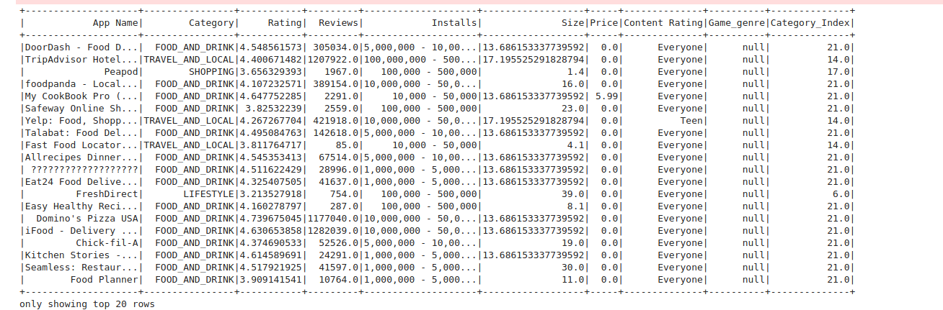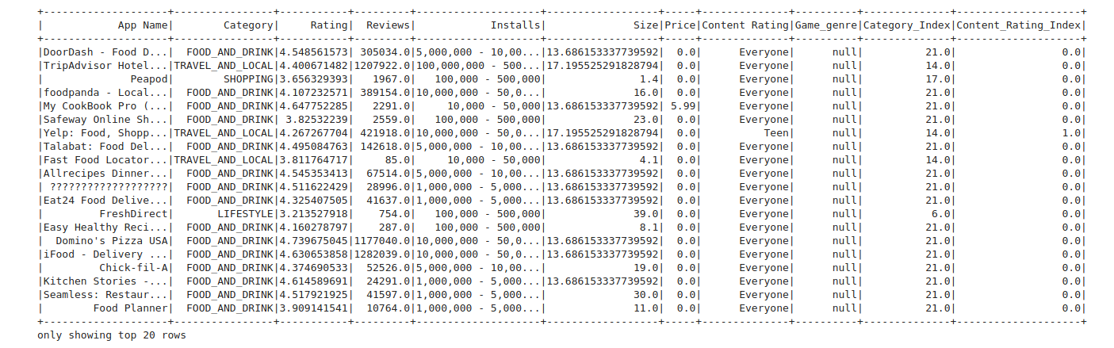

6.23 In describing the category data, one hot encoding can be more expressive. Many learning machines cannot use categorical information directly. The numerical transformation of the categories is required. Both category input and output variables require this . one hot encoding is done here for Category index and content rating index.

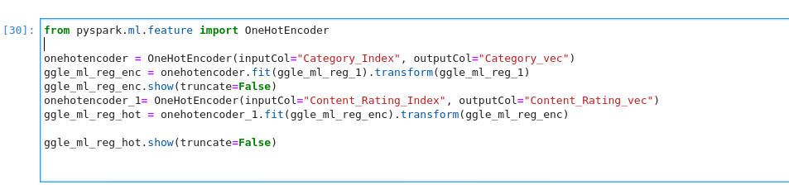

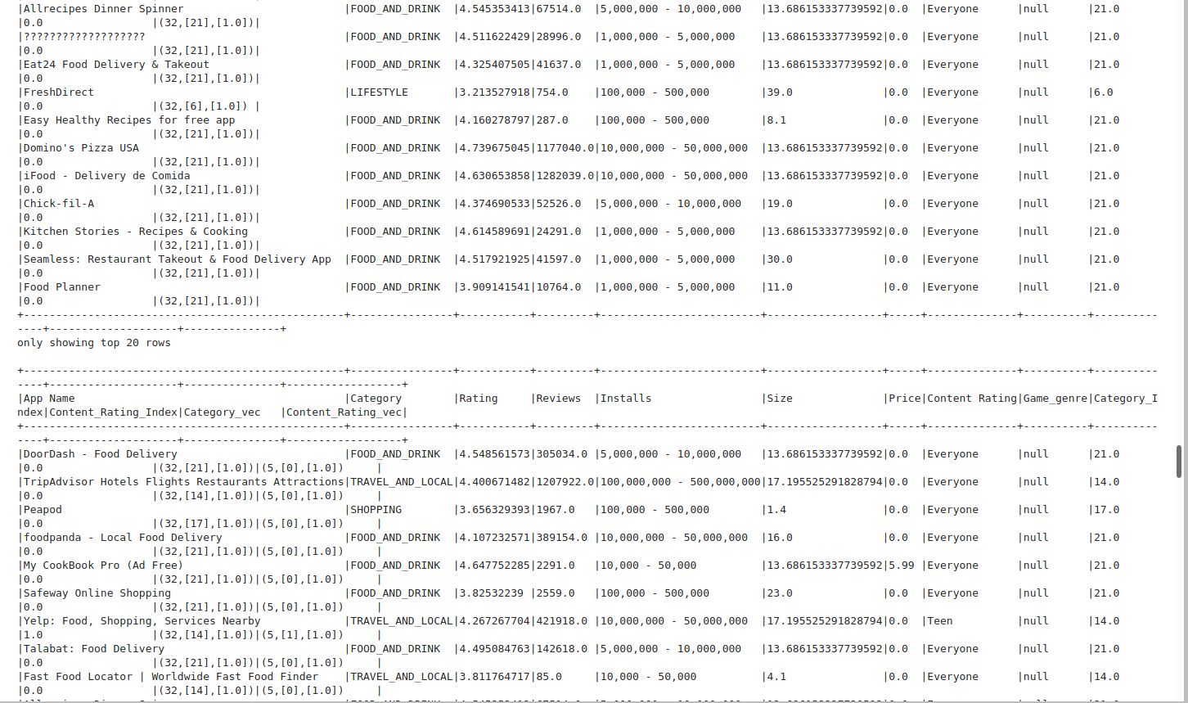

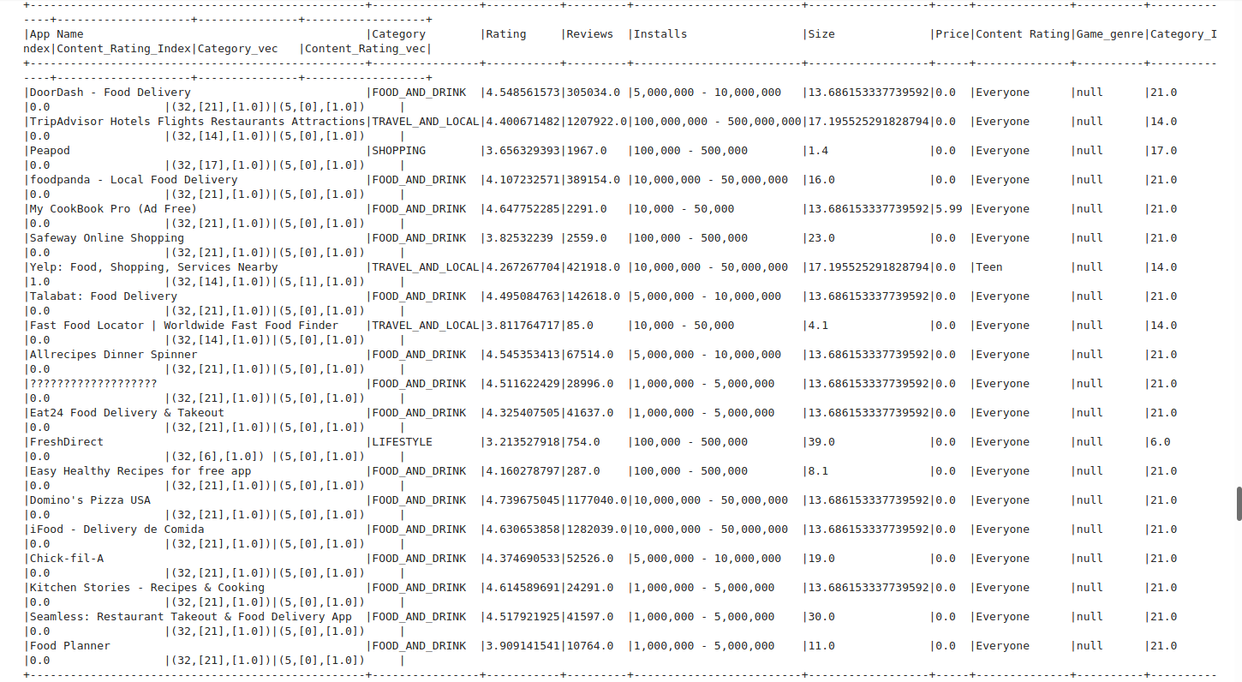

6.24 VectorAssembler combines a list of columns into a single column vector. Combining raw features and features derived by different feature converters into one vector is useful for training ML models such as logistical regression and Decision tree . VectorAssembler accepts the following input types: numeric, boolean, and vector. In the order specified in the vector, each row contains the values of the input columns.

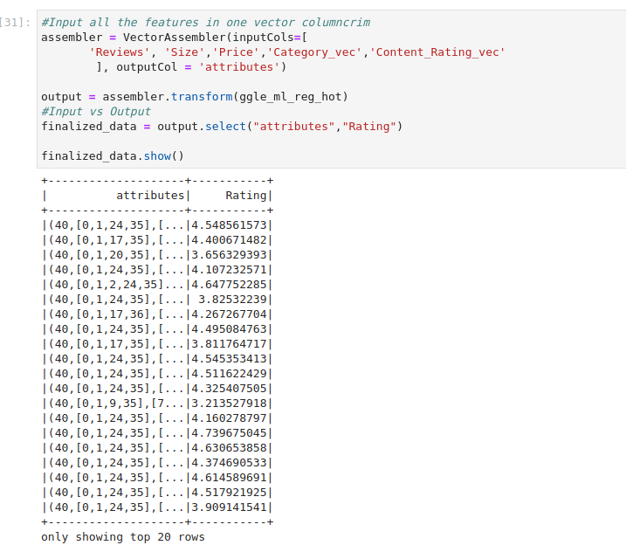

6.25 Checking for any null values , which turns out to be none .

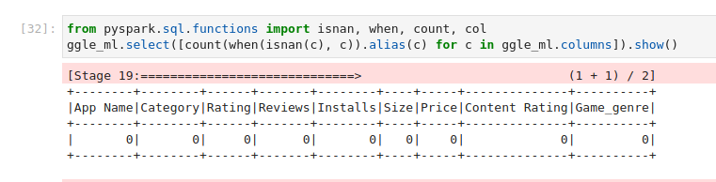

6 .26 splitting the data for training and testing in 80% train and 20% test. Linear regression algorithm code is implemented. which gives out the attributes, rating and the prediction as the end result.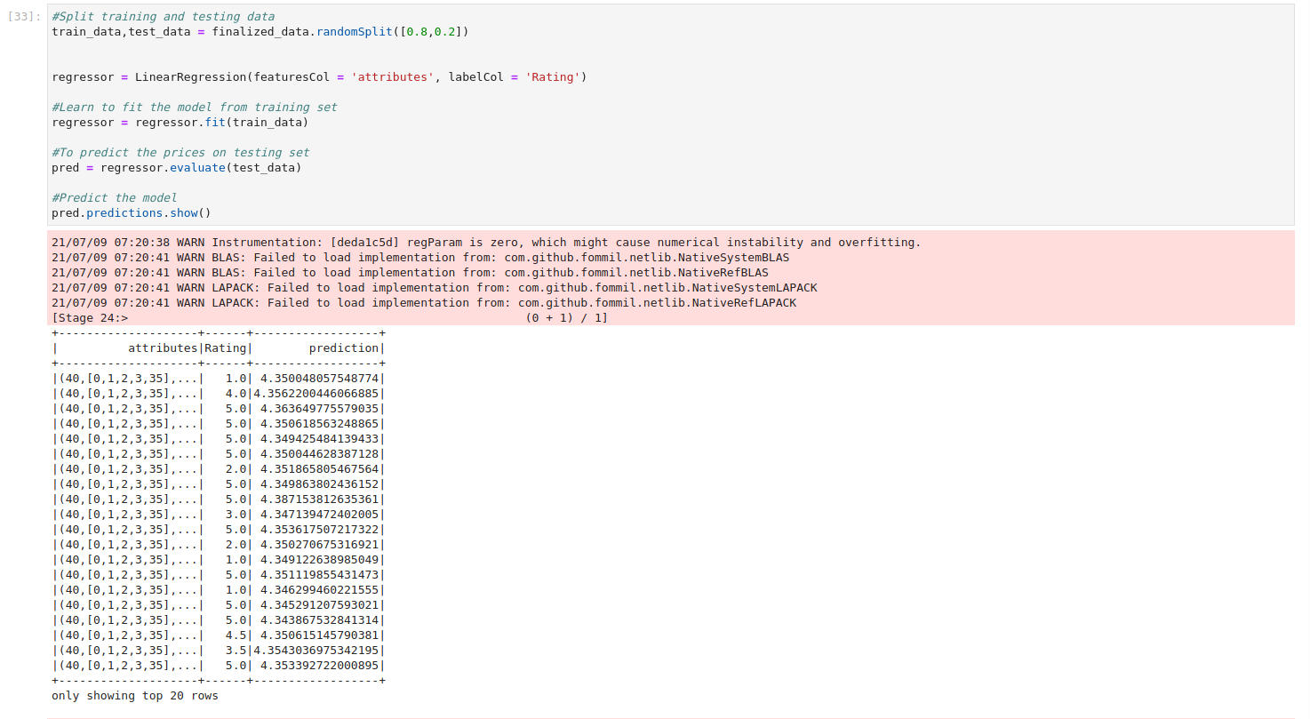

6.27 coefficients of this model are intercepted .

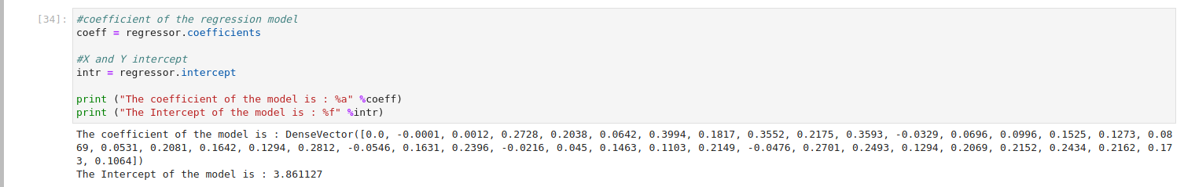

6.28 outcomes of linerar regressor model are shown.

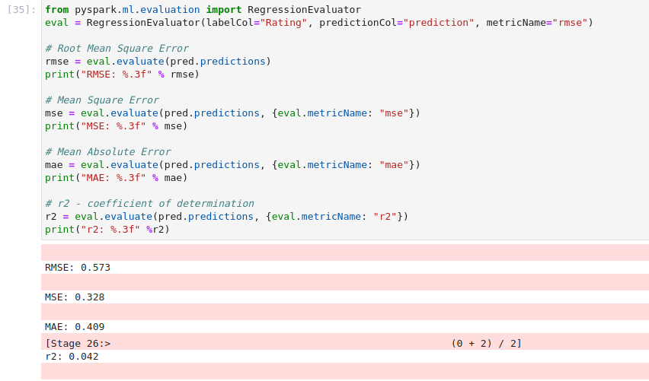

6.29 importing decisionTree Regressor from ML library in pyspark.

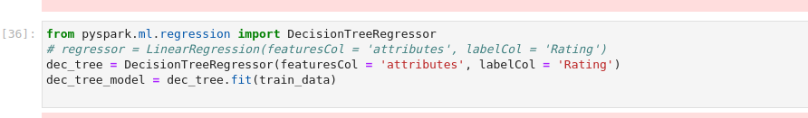

6.30 Running the codes with decission tree model to find the insights from it

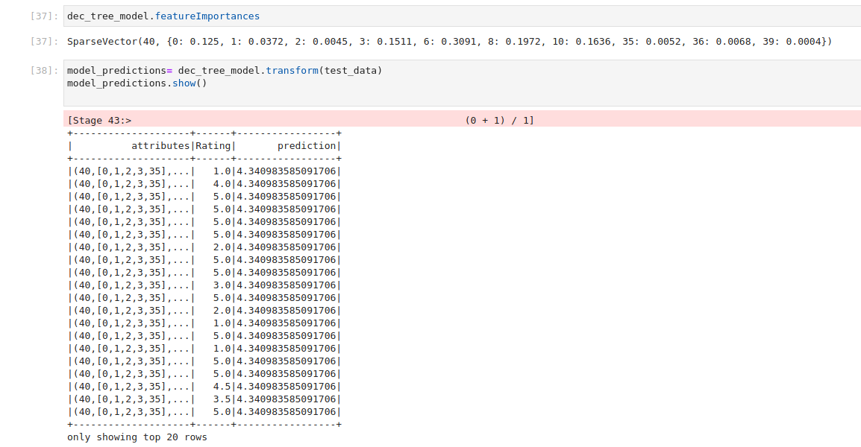

6.31 from decision tree finding out the rmse and r-square values .

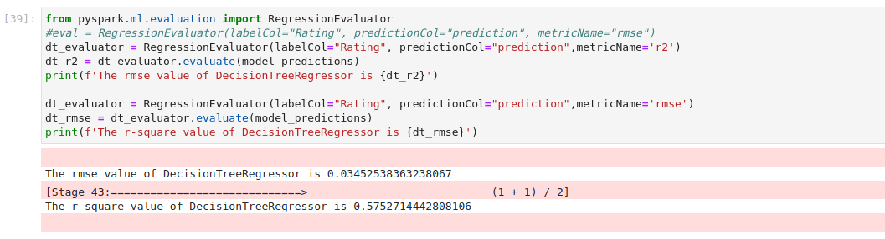

6.32 Implementing Random forest regressor with the code below 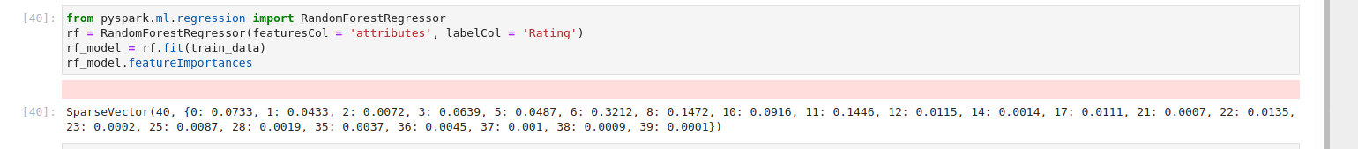

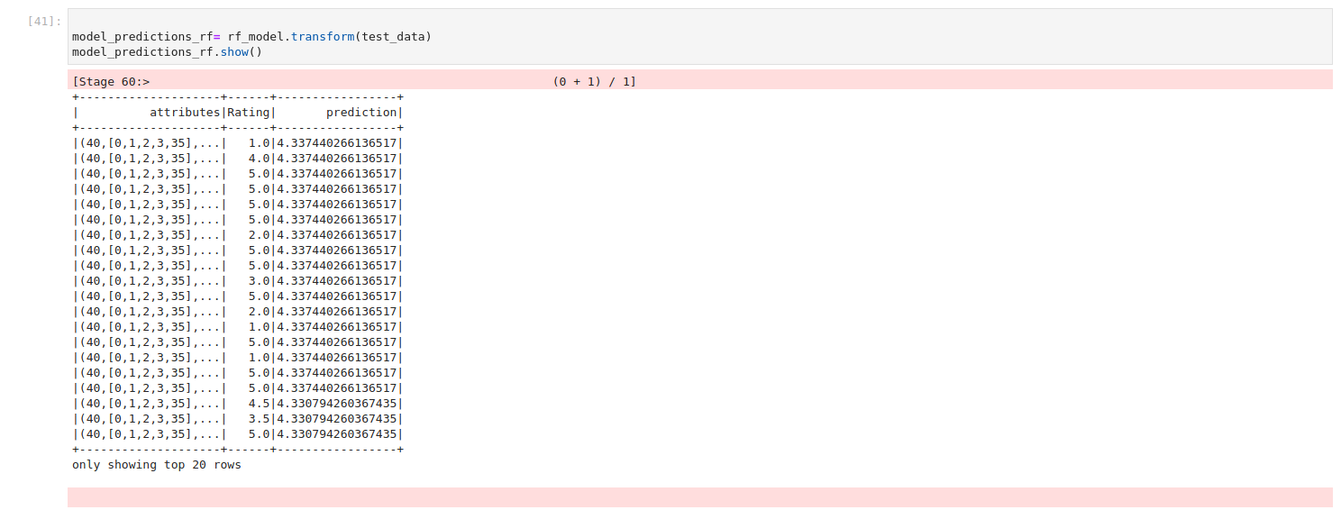

6.33 checking the number of trees produced by the decision tree and also the values of r-square and Rmse .

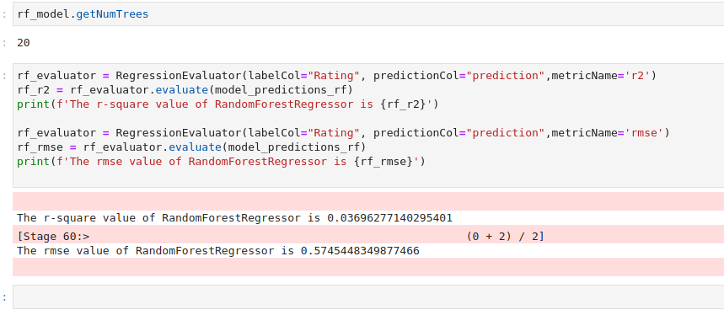

Discussion

Pyspark was quite quick in analysing this large dataset, which would have taken much longer otherwise, and its unique design was really useful in tackling this Big Data problem. Many attributes in the imported Google app store data were strings, which had to be transformed to Boolean and float datatypes for processing. Many qualities were not required for the analysis because some of them contained developer information that was not relevant to the analysis. Only the most important attributes were considered, while others were eliminated. The top 8 segments were examined for a better comprehension of the dataset because category included several types of repeated values regarding the segment in which apps were produced. Following data cleaning, we go to EDA, where the data is visualised using the Pandas library. Because many of the attributes were strings, the analysis was difficult to display, and only a few plots were created. We could see from the plots that the pricing was not determined by ratings, instals, or other factors, but rather by the developer taking into account the company's characteristics.

Using a cleansed dataset, machine learning methods were employed to forecast the application's ratings. Because the prior data set included a lot of null values, the dataset had to be cleaned manually because Pyspark made it difficult to clean the dataset. With all of these characteristics in mind, the model was formed, the three machine learning algorithms were run, and the results were analysed.

Conclusion

Many discoveries were made thanks to EDA, the most important of which is that the price of an app is not affected by user evaluations. Despite the fact that the goal was to estimate app ratings based on parameters like size, maximum and minimum installations, and Category, the R-SQUARE values were lower than expected. Cleaning data was one chore that Pyspark didn't like, despite the fact that Pyspark worked well on platforms like Ubuntu. Many attributes were ignored, despite the fact that data type conversions were performed, because the values were not relevant to the study.

Appendix

The code with the data set are available here in the link below

https://drive.google.com/drive/u/2/folders/1QARzA-8496tRfSyLhpBMjSo-iejVX_wT